Aim: Identify core-periphery ties using two-mode analysis
To be discussed in class: Core-periphery structures - Two-mode networks - Centrality measures
import networkx as nx
import matplotlib.pyplot as plt

#Create Bipartite Graph
B=nx.Graph()

#Define Two Sets of nodes
actors=['Alice','Bob','Charlie','David','Eva']
movies=['M1','M2','M3','M4']

#Add nodes with a "bipartite attribute
B.add_nodes_from(actors, bipartite=0) #Top Set
B.add_nodes_from(movies, bipartite=1) #Bottom Set

#Define edges(Who acted in which movie)
edges=[
('Alice','M1'), ('Bob','M1'),('Charlie','M1'),('Eva','M1'),
('Alice','M2'),('David','M2'),('Eva','M3'),
('Bob','M4'),('Charlie','M4'),('Eva','M4')
]
B.add_edges_from(edges)

#Step 3: Visualize the Two-Mode Network
from networkx.algorithms import bipartite
pos=nx.spring_layout(B)
nx.draw(B,pos,with_labels=True, node_color='orange',edge_color='green', node_size=1500)
plt.title("Two Mode Network: Actors and Movies")
plt.show()
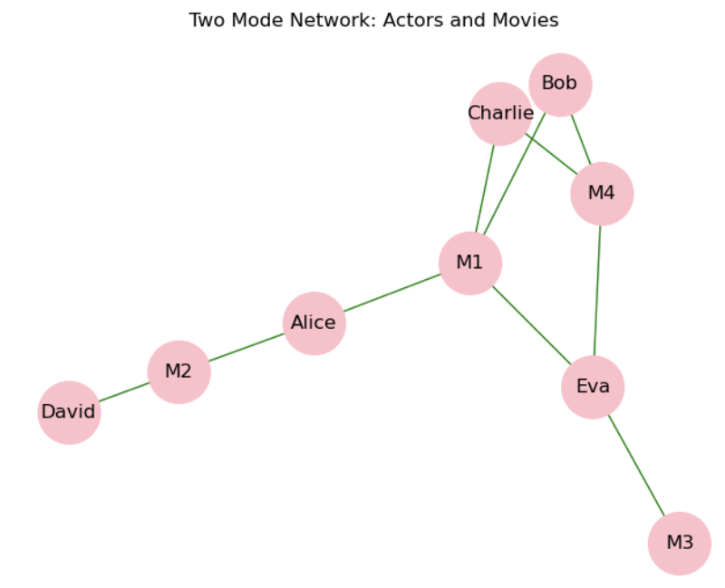
#Step 4: Project to One-Mode (Actor-Actor Network)
actor_graph=bipartite.projected_graph(B, actors)

#Visualize
nx.draw(actor_graph,with_labels=True, node_color="pink", node_size=2000,edge_color='green')
plt.title("Actor Co-participation Network")
plt.show()
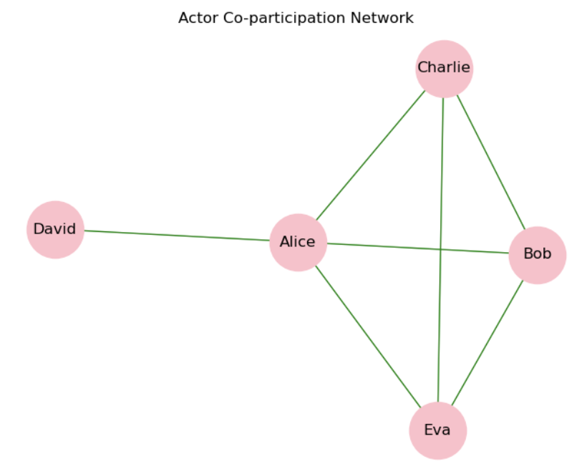

#Centrality measures
deg_cent=nx.degree_centrality(actor_graph)
eig_cent=nx.eigenvector_centrality(actor_graph)
btw_cent=nx.betweenness_centrality(actor_graph)

#Display Results
for actor in actors:
print(f"{actor}: Degree={deg_cent[actor]:.2f},Eigenvector={eig_cent[actor]:.2f},Betweenness={btw_cent[actor]:.2f}")

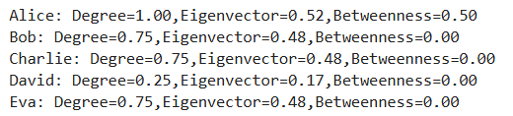

Case Study: Corporate Board Memberships - Identify core-periphery ties in a
corporate board network (directors vs. companies).
import networkx as nx
from networkx.algorithms import bipartite
import matplotlib.pyplot as plt
# 1. Create Bipartite Graph
B = nx.Graph()
# 2. Define Two Sets of Nodes (Indian Names & Companies)
directors = ['Aarav', 'Ananya', 'Rohan', 'Pooja', 'Vikram']
companies = ['TataCorp', 'InfosysLtd', 'RelianceInd', 'WiproTech']
# Add nodes with bipartite attribute
B.add_nodes_from(directors, bipartite=0) # Director set
B.add_nodes_from(companies, bipartite=1) # Company set
# Define edges (Which directors sit on which company boards)
board_memberships = [
('Aarav', 'TataCorp'), ('Ananya', 'TataCorp'), ('Rohan', 'TataCorp'), ('Vikram', 'TataCorp'),
('Aarav', 'InfosysLtd'), ('Pooja', 'InfosysLtd'), ('Vikram', 'InfosysLtd'),
('Rohan', 'RelianceInd'),
('Ananya', 'WiproTech'), ('Rohan', 'WiproTech'), ('Vikram', 'WiproTech')
]
B.add_edges_from(board_memberships)
# 3. Visualize Two-Mode Network (Bipartite Layout)
pos = nx.bipartite_layout(B, directors)
plt.figure(figsize=(8, 6))
nx.draw(B, pos, with_labels=True, node_color=['skyblue' if node in directors else 'lightgreen' for node in B],
node_size=3000, font_weight='bold', edge_color='gray')
plt.title("Two-Mode Network: Indian Corporate Board Memberships")
plt.show()

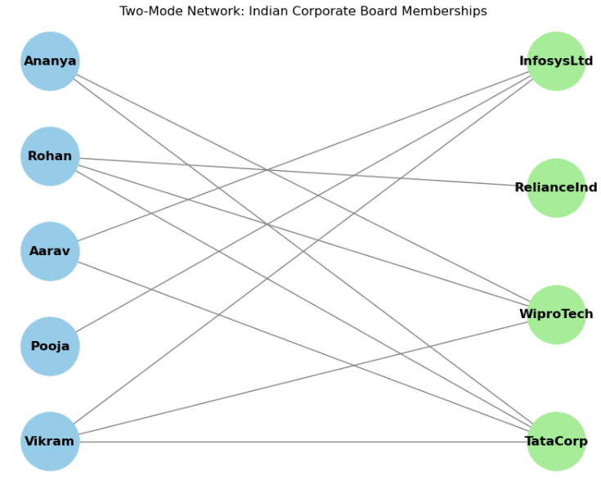

# 4. Project to One-Mode (Director-Director Interlock Network)
director_graph = bipartite.projected_graph(B, directors)

# Visualize One-Mode Director Network
plt.figure(figsize=(7, 5))
nx.draw(director_graph, with_labels=True, node_color="gold", node_size=2000, edge_color='purple', font_weight='bold')
plt.title("Director Interlock Network (One-Mode)")
plt.show()

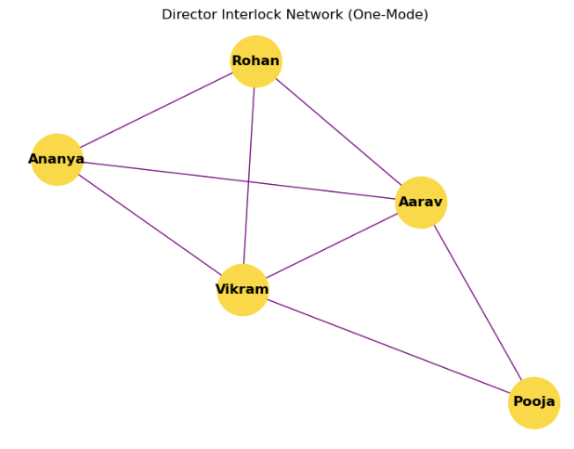

# 5. Calculate Centrality Measures to Identify Core vs. Periphery
deg_cent = nx.degree_centrality(director_graph)
eig_cent = nx.eigenvector_centrality(director_graph)
btw_cent = nx.betweenness_centrality(director_graph)

# Display Results
print("\n--- DIRECTOR CENTRALITY & CORE-PERIPHERY ANALYSIS ---")
for director in directors:
print(f"{director:7s} | Degree={deg_cent[director]:.2f} | Eigenvector={eig_cent[director]:.2f} | Betweenness={btw_cent[director]:.2f}")

